**VIETNAM NATIONAL UNIVERSITY, HANOI**

**UNIVERSITY OF ENGINEERING AND TECHNOLOGY**



**Software Engineering**

**QuizManagement**

**Class: K56CA**

**Vo Thanh Tung**

**Tran Duc Thanh**

**Hy Truong Son**

**Hanoi 2013**

Contents

1. Introduction 3

1.1. Author 3

1.2. Product 3

2. Model - Control - View

2.1. Model layer 4

2.2. View layer 4

2.3. Controller layer 4

3. Design 4

3.1. Requirements 4

3.2. Design and Analysis 5

4. Function – How to use 6

4.1. Log in – Log out 6

4.2. Answer a question 7

4.3. Question manager 8

4.4. User manager 9

5. Conclusion 9

# Introduction

# The QuizManagerment is a software developed to help students who want to test and play some quiz such as multiple chosen questions.

## Author

Group 10 – K56CA University of Engineering and Technology, Vietnam National University, Hanoi. We are Vo Thanh Tung, Tran Duc Thanh and Hy Truong Son.

## Product

This software was developed by PHP using Cake framework running on Xampp.

# Model - Control – View

## Model Layer

## The Model layer represents a part of our application that implements the business logic. It is responsible for retrieving data and converting it into meaningful concepts for our application. This includes processing, validating, associating or other tasks relating to handling data.

* At a first glance, Model objects can be seen as the first layer of interaction with any database you might be using for your application. But in general they stand for the major concepts around which we implement our application.
* In the case of a social network, the Model layer would take care of tasks such as saving the user data, saving friends associations, storing and retrieving user photos, finding new friends for suggestions, etc. The model objects can be thought as “Friend”, “User”, “Comment”, or “Photo”.

## 2.2. View Layer

* The View renders a presentation of modeled data. Being separated from the Model objects, it is responsible for using the information available to produce any presentational interface our application might need.
* For example, as the Model layer returns a set of data, the view would use it to render a HTML page containing it. Or a XML formatted result for others to consume.
* The View layer is not only limited to HTML or text representation of the data, it can be used to deliver a wide variety of formats depending on your needs, such as videos, music, documents and any other format you can think of.

## 2.3. Controller layer

* The Controller layer handles requests from users. It is responsible for rendering back a response with the aid of both the Model and the View Layer.
* Controllers can be seen as managers taking care that all needed resources for completing a task are delegated to the correct workers. It waits for petitions from clients, checks their validity according to authentication or authorization rules, delegates data fetching or processing to the model, and selects the correct type of presentational data that the client is accepting, to finally delegate this rendering process to the View layer.

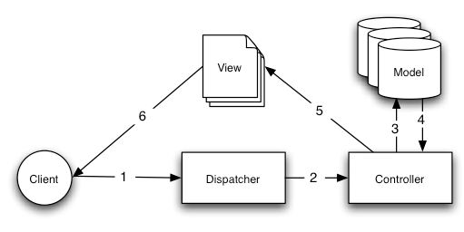

# Design

## Requirements

* This software can create questions for users, who will take part in the test. There are three types of users including Admin, Mode and User.
* Before taking this software, a user must to create a new account and login to the server. Without an account, you can register by using email address.
* **Admin:** has right to delete an account of user, edit the profile of user, upgrade an user account to a mod account.
* **Mod:** has right to create new questions, delete questions, classify questions into some category.
* **User**: has right to take a test and edit their profile.

## Design and Analysis

## User case Diagram

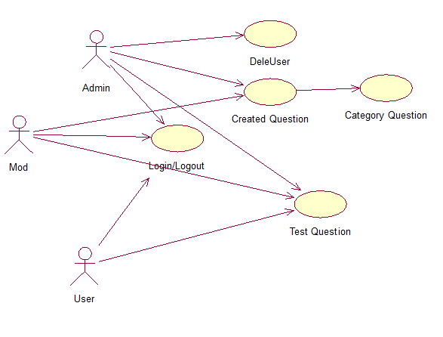

1. Sequence Diagram

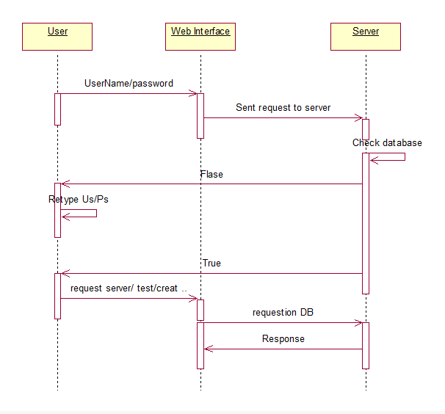

# Functions – How to use

## Log in – Log out

To use the software, we need a browser to type address of the web (in this project we used Xampp to create a local host to test the software). You can see how to figure this here:

* + If had an account before, you only need to type your username and account on blank and submit. If you do not have any account, you need to create one by clicking Register at the bottom of the site.
  + When logining to the server, if you submited your right username and password, you will have your user function which may be admin, mod or user. However if you submited wrong, you must to retype your password and username.

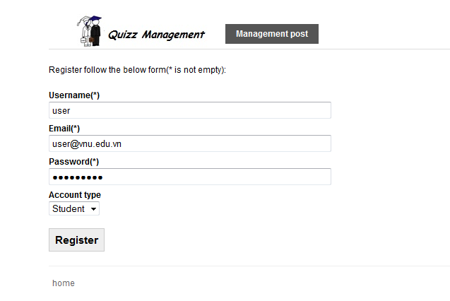

* 1. **Answer a question**

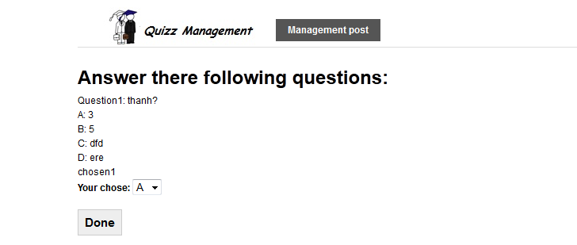

## Question manager

## Create a new category.

## Create a new question.

## Delete questions.

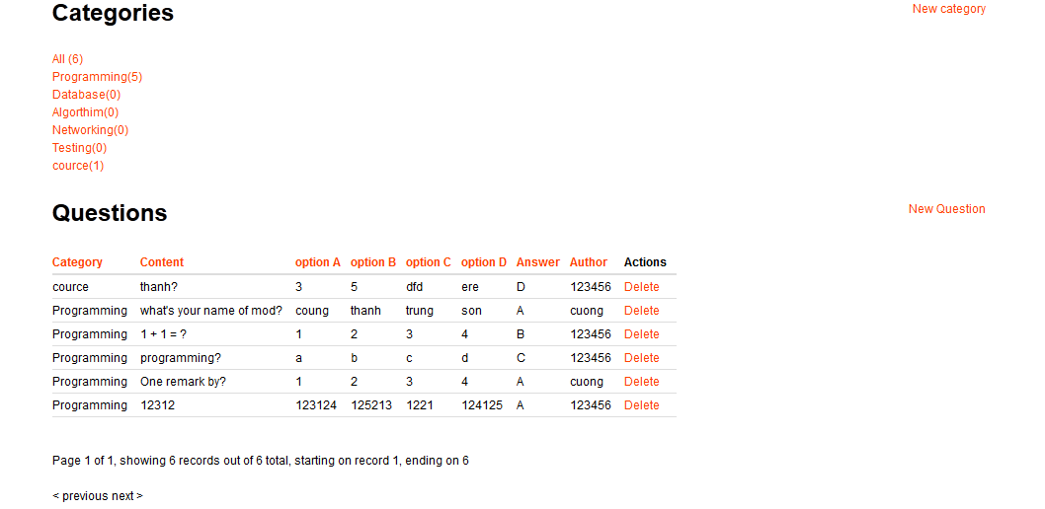

* 1. **User manager**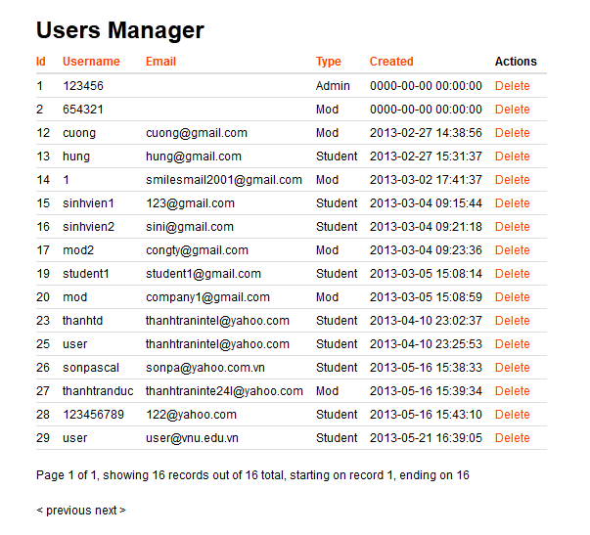

# Conclusion

In this assignment, we created the project Quiz Management using framework Cake for PHP running on Xampp. In this project, we have done the work below:

* Study and understand about mode MVC to use developed web. Use PHP as a language for programming and SQL to query the database and use them.
* Analysis and design the software. Use the rational rose to create user case diagram and sequence diagram.
* Build the plant for developing the software: specific requirements, testing program, some types of other developed softwares.
* Team work. There are 3 students in this group and we have been working efficiently. We have divided the work into smaller tasks and each student has responsibility to finish some of these small tasks.
* For example, one student wrote this document, one student studied about PHP and the other used tools for creating the plan suchas Github, etc.